SynergySoft Scheduler System

System Requirements Specification

Prepared by the design firm of

Bouchier, Fischer, Herschbach and Nina

Version 0.1

October 7, 2015

Table of Contents

Table of Contents i

Revision History iii

1. Introduction 1

1.1 Purpose 1

1.2 Product Scope 1

1.3 Glossary 1

1.4 References 1

1.5 Overview 1

2. General Description 2

2.1 Product Perspective 2

2.1.1 System interfaces 2

2.1.2 User interfaces 2

2.1.3 Hardware interfaces 2

2.1.4 Software interfaces 2

2.2 Product Functions 3

2.2.1 Enterprise Requirements 3

2.3 User Characteristics - Jon 7

2.4 Constraints 8

2.5 Assumptions and Dependencies 8

2.6 Apportioning of Requirements - Jon 8

3. Specific Requirements 9

3.1 External Interfaces 9

3.2 Functions 12

3.2.1 Use Case: 1 Respond To Meeting Invitation 12

3.2.2 Use Case: 2 Initiate a meeting 14

3.2.3 System Functional Requirements 16

3.2.4 Nonfunctional Requirements 20

3.2.5 Deleted Requirements 24

3.2.6 System Non-functional Requirements 25

3.2.7 Deleted Requirements 25

4. Requirements Analysis – Paul & Shaun 25

4.1 Analysis Team and Roles - Paul 25

4.2 Analysis Process 26

4.3 Dependency Analysis 26

4.3.1 Enterprise Requirements Analysis 26

4.3.2 System Functional Requirements Analysis 27

4.3.3 System Nonfunctional Requirements Analysis 28

4.4 Issues Raised to SynergySoft - Shaun 29

4.5 Original Requirements Delivered by SynergySoft 30

4.5.1 ORIGINAL Enterprise Requirements: Stakeholders, Functional and Non-Functional Objectives 1

4.5.2 ORIGINAL System Requirements: Functional Requirements 1

4.5.3 ORIGINAL System Non-Functional Requirements 2

Revision History

|  |  |  |  |
| --- | --- | --- | --- |
| **Name** | **Date** | **Reason For Changes** | **Version** |
| Paul Bouchier | 10-06-06 | Initial Version | 0.1 |
|  |  |  |  |
|  |  |  |  |
|  |  |  |  |
|  |  |  |  |
|  |  |  |  |
|  |  |  |  |
|  |  |  |  |
|  |  |  |  |
|  |  |  |  |

# Introduction

## Purpose

The purpose of this document is threefold:

1. To explain the process by which the preliminary requirements from SynergySoft Corporation were analyzed and refined
2. To state the requirements for the SynergySoft Meeting Scheduling System in a way that allows tracing from the original (ambiguous, unrefined) form to the analyzed and refined form.
3. To show the analysis of the requirements (dependencies, issues resolved, how the requirements have been understood, etc.)

Therefore, this document is more than a requirements specification – it is also a statement of how the requirements were derived from the input, and how the requirements relate to each other.

## Product Scope

The product is a software application which is accessed from a web browser and used to schedule meetings.

## Glossary

This subsection contains definitions of all the terms, acronyms, and abbreviations used in the document. Terms and concepts from the application domain are defined.

## References

* IEEE 830-1998
* CS6354 Project Documentation, by Bouchier, Brewster, Fischer, Herschbach, Nina
* Project submissions from CS6361, Summer 2006

## Overview

This document is laid out in a modified IEEE830-1998 style. The biggest difference from the standard is the addition of section 4, which describes the process used to produce this document. The following information is in this document:

* Section 2: General description of product, including user interface screen shots, dependency analysis, and enterprise requirements.
* Section 3: Functional & Non-functional requirements. Note that all non-functional requirements are grouped into one category, and not distributed among categories, as in IEEE830. Section 3 also covers use cases and deleted requirements.
* Section 4 describes the requirements analysis process.

# General Description

This system is designed to be a facility for scheduling meetings and has many potential applications, such as scheduling courses and flights, room assignments at hospitals and hotels, scheduling national and international meetings, logistics, job scheduling in production systems, as well as command and control systems.

The particular type of system is intended to support people in order to schedule their meetings. Many software vendors have attempted to offer such a system, especially one with a powerful vantage point (d., Microsoft, IBM-Lotus, etc.). However, SynergySoft, Inc. aims to provide a product which would outperform any such system that is currently available in this highly competitive market.

The system which SynergySoft, Inc. intends to build makes a step beyond the products currently on the market and intends to make it self known as the best tool for scheduling in the industry. To do this, the system must be distributed in a way never before done, as well as robust enough to handle any size problem set. The ability to handle high level of demands while being user friendly enough for day to day scheduling is one of many keys to the success of the system. If the system developed is not realistic to utilize in business, then it will quickly fall out of favor with clients and fail. This above nearly all else, must be central to the design and implementation of the system.

## Product Perspective

The SynergySoft, Inc. Scheduler system is a virtually self contained scheduling system; however, it will require users to have access to a web browser on their workstation computer. This means that the users of the system do not need to invest in any other software to get the most out of the software system as any Windows based PC comes installed with a web browser, and any non Windows machine can use FireFox or other freeware browsers. The system will also have the ability to send email notifications to users when a new item is sent to their scheduling system account. This feature is built into the Scheduler and does not require any other software to function.

### System interfaces

As stated in section 2.1 the Scheduler system is a self contained system, relying on very little in the way of external software interfaces. However, the system will require interfaces with the installed computer’s hardware. The system is to be a web-enabled system, meaning that all user interaction is done through a web browser. The System interfaces required on the system server are the following:

* Network interface to a network with an internet connection
* Database connection to the mySQL database containing user and schedule data

### User interfaces

All user interfaces other than initial installation occur through a web page.

### Hardware interfaces

There are no hardware interfaces to this system.

### Software interfaces

The system will interface to an email system using SMTP.

## Product Functions

The Enterprise functional & non-functional requirements requirements from SynergySoft have been analyzed and all issues and ambiguities resolved. In some cases, the resolution is a deviation from the requirements supplied by SynergySoft. This document is for review by SynergySoft project management & marketing, and the changes to the spec should be analyzed for acceptability to SynergySoft.

See section 4 for the process used to analyze the requirements, and to generate the modified enterprise requirements below. Each requirement below has a trace back to the line number in the original requirements specification, which is shown in section 4. They also note if there is a dependency diagram object related to the requirement. Each requirement below that was modified from the original has a Note in the requirement description, which describes how it was modified. SynergySoft reviewers need to review the changes that were made to the delivered requirements, to ensure they are agreeable.

### Enterprise Requirements

**2.2.1.1 ) Any user can create meeting [POS51815** Version:1.7**]**

Any user with an account on the system shall be permitted to create a meeting invitation, and shall be able to invite anyone else on the system to the meeting.

Rationale: The SynergySoft spec is silent on this point, but our user rep says this is how it needs to be.

Enterprise Dependency Diagram: Initiator

**Requirement Tracing:**

FUN51794 Manage Participant Interactions Requirement BouchierCs6361 Direct TO

POS51775 Meeting Initiator Requirement BouchierCs6361 Direct TO

NONFUN51807 Decentralized requests Requirement BouchierCs6361 Direct TO

NONFUN51814 Extensible Requirement BouchierCs6361 Direct TO

NONFUN51805 Reflects current meeting management Requirement BouchierCs6361 Direct TO

**2.2.1.1.1 ) Meeting Initiator [POS51775** Version:4.6**]**

The meeting initiator can be one of the participants, or some representative such as a secretary

Traces from Enterprise Requirements lines: 29

Enterprise Dependency Diagram: Initiator

**Requirement Tracing:**

FUN51787 Assist planning meetings Requirement BouchierCs6361 Direct TO

FUN51788 Assist replanning meetings Requirement BouchierCs6361 Direct TO

POS51815 Any user can create meeting Requirement BouchierCs6361 Direct FROM

POS51770 Conflict Resolution Policies Requirement BouchierCs6361 Direct FROM

POS51765 Meeting date range Requirement BouchierCs6361 Direct FROM

POS51818 System Administrator Requirement BouchierCs6361 Direct TO

**2.2.1.2 ) Initiator asks attendees for schedule [POS51764** Version:6.0**]**

A meeting initiator will ask all potential meeting attendees for the following information:

* A set of dates & times on which they cannot attend the meeting (the exclusion set)

* A set of dates & times on which they would prefer the meeting to take place (the preference set)

Traces from Enterprise Requirements lines: 3-6

Enterprise Dependency Diagram: Initiator

**Requirement Tracing:**

**2.2.1.2.1 ) Meeting date range [POS51765** Version:3.1**]**

The request for dates is limited to a certain range of time in the future.

Traces from ER line 8;

Enterprise dependency: Date Range

**Requirement Tracing:**

POS51775 Meeting Initiator Requirement BouchierCs6361 Direct TO

**2.2.1.2.1.1 ) Meeting Date [POS51816** Version:1.0**]**

A meeting date shall comprise a date and a start-time and a duration for the meeting. A meeting date is a single occurrence. Recurring meetings are not addressed by this requirement.

Rationale: This requirement clarifies the meaning of the SynergySoft spec.

Traces from Enterprise Requirements lines: 7

Enterprise Dependency Diagram: Meeting Date

**Requirement Tracing:**

**2.2.1.2.2 ) Equipment Requirements [POS51766** Version:4.1**]**

The initiator shall ask active participants to state special equipment requirements

Traces from Enterprise Requirements lines 9-10

Enterprise Dependency Diagram: Equipment

Notes: The SynergySoft spec said "can ask" - we clarified it to "shall ask" after consultation with user & domain reps.

**Requirement Tracing:**

POS51818 System Administrator Requirement BouchierCs6361 Direct TO

**2.2.1.2.3 ) Preferred locations [POS51767** Version:4.1**]**

The initiator shall ask important participants to state preferences for meeting location

Traces from Enterprise Requirements lines: 11

Enterprise Dependency Diagram: Important Participants, Meeting Location

Notes: The SynergySoft spec said "can ask" - we clarified it to "shall ask" after consultation with user & domain reps

**Requirement Tracing:**

POS51818 System Administrator Requirement BouchierCs6361 Direct TO

**2.2.1.3 ) Proposed Meeting date [POS51768** Version:2.0**]**

The proposed meeting date belongs to the stated date range and to none of the exclusion sets, and should belong to as many preference sets as possible, and is made as early as possible.

Traces from Enterprise Requirements lines: 12-13

Enterprise Dependency Diagram: Meeting Date, Inclusion Set, Exclusion Set, Date Range

**Requirement Tracing:**

**2.2.1.3.1 ) Date Conflict [POS51769** Version:3.1**]**

A date conflict occurs when no date can be found that meets the requirements for a proposed meeting date. A conflict is strong when no date can be found within the date range and outside all exclusion sets. A conflict is weak when dates can be found within the date range and outside all exclusion sets, but there is no date that is in all preference sets.

Traces from Enterprise Requirements lines: 14 - 16

Enterprise Dependency Diagram: Date Conflict

**Requirement Tracing:**

FUN51797 Negotiation & conflict resolution Requirement BouchierCs6361 Direct TO

**2.2.1.3.2 ) Conflict Resolution Policies [POS51770** Version:3.3**]**

Conflicts can be resolved in several ways, including:

* Initiator extends date range

* Some participants remove dates from their exclusion set

* some participants withdraw from the meeting

* some participants add new dates to their preference set

* The meeting can be cancelled

If there's a strong conflict, the initiator must choose which conflict resolution method to use - the system will not choose a date with a strong conflict.

If there's a weak conflict, the system shall pick the earliest meeting date that doesn't have any strong conflicts.

Traces from Enterprise Requirements lines: 17-21

Enterprise Dependency Diagram: Conflict Resolution

Notes: The SynergySoft didn't say much about how to choose a date when there's a conflict. After consultation with user & domain reps, we chose policies for dealing with weak & strong conflicts. Line 41 suggested a meeting may be cancelled in certain types of conflict, so we added this to the list of available conflict resolution techniques.

**Requirement Tracing:**

POS51775 Meeting Initiator Requirement BouchierCs6361 Direct TO

FUN51793 Conflict Resolution Policies Requirement BouchierCs6361 Direct TO

POS51772 Meeting Room Available SUSPECT Requirement BouchierCs6361 Direct TO

**2.2.1.3.2.1 ) Quick and convenient resolution [POS51771** Version:2.0**]**

Each conflict should be done as quickly as possible and with no more interaction than is really needed

Traces from Enterprise Requirements lines: 22-23

Enterprise Dependency Diagram: Performed Quickly, Minimal Interaction

**Requirement Tracing:**

**2.2.1.4 ) Meeting Room Available [POS51772** Version:4.0**]**

A meeting room must be available at the selected meeting date. It should meet the equipment requirements; furthermore it should ideally belong to one of the locations preferred by as many important participants as possible. Meeting room unavailability and equipment unavailability shall result in strong conflicts. Unavailability of the preferred location shall produce a weak conflict. In either case, conflict resolution shall be used to resolve the conflict.

Traces from Enterprise Requirements lines: 24-25

Enterprise Dependency Diagram: Meeting Room, Meeting Location

Notes: The SynergySoft spec didn't say what to do if meeting room or equipment was unavailable. We chose to treat meeting room and equipment unavailability the same as a participant with an exclusion set which corresponds to the unavailability of a suitable room or equipment; and where the location availability is treated the same as a participant with an inclusion set which corresponds to the available dates.

**Requirement Tracing:**

POS51770 Conflict Resolution Policies SUSPECT Requirement BouchierCs6361 Direct FROM

**2.2.1.5 ) Minimize Negotiation [POS51817** Version:2.0**]**

The number of negotiations should be kept minimal. but a new round of negotiation may be required when no room can be found for a proposed meeting date.

Traces from Enterprise Requirements lines: 27-28

Enterprise Dependency Diagram:

**Requirement Tracing:**

**2.2.1.6 ) Virtual meeting [POS51773** Version:2.1**]**

Each meeting may take place in a virtual place, e.g. through teleconferencing through laptop computers.

Traces from Enterprise Requirements lines: 26

Enterprise Dependency Diagram:

**Requirement Tracing:**

POS51774 Importance of virtual meeting Requirement BouchierCs6361 Direct TO

**2.2.1.6.1 ) Importance of virtual meeting [POS51774** Version:2.1**]**

The flexibility to hold virtual meetings is considered crucial in the future

Traces from Enterprise Requirements lines: 27

Enterprise Dependency Diagram:

**Requirement Tracing:**

POS51773 Virtual meeting Requirement BouchierCs6361 Direct FROM

**2.2.1.7 ) System Administrator [POS51818** Version:1.2**]**

There shall be a person or persons in the organization who are responsible for administering the system and keeping the system's knowledge of rooms, user accounts, etc. current.

Notes: The whole administration area was not addressed in the SynergySoft spec. After consultation with the domain rep we decided there needs to be an administrator. We need to point this out to SynergySoft, because it affects manpower requirements.

**Requirement Tracing:**

FUN51820 Administrative Account Requirement BouchierCs6361 Direct TO

POS51766 Equipment Requirements Requirement BouchierCs6361 Direct FROM

POS51775 Meeting Initiator Requirement BouchierCs6361 Direct FROM

POS51767 Preferred locations Requirement BouchierCs6361 Direct FROM

## User Characteristics - Jon

There are three types of users in this system. The first two are, authorized users, and non authorized users, the only distinction between them is that authorized users are allowed to see the preference and exclusion sets of other users. It is the third type of user, the administrator, who is able to initially setup the system, add new users, and set their authorization level.

Most users will be of the type non-authorized. These users are able to accept or decline schedule invitations, set their preferences or schedule meetings. However, during the schedule meeting event, they will not be able to view the selected participants preference or exclusion set. This means that the system will be 100% relied upon to ensure that a meeting time and location is found. If a meeting time is not found, then the non-authorized user has to pick a resolution choice without knowing what may resolve the issue the easiest.

The next most common type of user is the authorized user. These users have the same permissions as the non-authorized user with the additional ability to view other users preference and exclusion set. This ability allows them to visibly check who among their selected participants may cause a meeting to have a conflict and contact them directly before sending out the invitations for the meeting. This may help prevent some conflicts from occurring before the meeting is even entered into the system. However, this advantage really is only helpful for small meetings of limited number of individuals or meetings with a few important people who would determine the time and location.

Finally, the system administrators are users who are able to setup the system from the initial installation and maintain the systems user accounts. They automatically have the functionality of authorized users within the normal operation of the system, however have additional menu options which allow them to maintain the system.

All users have to have basic computer skills which include working with a web browser such as Internet Explorer or FireFox. Since all interaction with the UI of the system is through a browser window, the system can not be used without access and knowledge of web browser functionality.

## Constraints

There are a number of constraints which the system must abide by during development. The system must be developed within their bounds. These constraints dictate a number of the functional and nonfunctional requirements specified by this document. Others are because of a requirement specified to us by our customer. All are important to be aware of during the implementation of the software system.

* System is to be developed for distributed use as a web application. This will limit the ability for real time updates to the system.
* System is to be developed in Java through Servelets and JSP pages.
* Data must be stored in a relational database for quick queries and storage.
* Passwords must be sent and stored in encrypted form.
* Some users are authorized users while some are non-authorized users. Non-authorized users can not see other user’s preference and exclusion sets.
* System must be robust enough to handle virtual meetings through teleconferencing, etc.
* System must handle rescheduling meetings with no outside input from initiator unless conflict arises
* System must be able to send email notifications to any common email server promptly and correctly
* Keep user overhead to an absolute minimum. Anywhere the system can handle a decision itself, it must do so.
* Server-Client communication must be done over TCP connections
* Meetings can be rescheduled up to 24hrs prior to their current start time.

## Assumptions and Dependencies

* + . System will be installed on a machine running Windows operating system, Tomcat and mySQL 5.0 or newer.
  + Monitoring as stated in the requirements given to us by the customer means that it monitors changes to the participant’s preference and exclusion set and reschedules the meeting if needed.
  + Monitoring the actual meeting content is not within the scope of this product and has been removed from the requirements.
  + The meeting initiator will control who the important participants of a meeting are.
  + The meeting initiator will decide on what form of conflict resolution to persue.
  + A meeting can not be rescheduled within 24hrs of meeting start time (defined lower bound).
  + A meeting can be rescheduled a maximum time of 3 times (defined upper bound).
  + Users will use this system as their primary calendar for keeping track of meetings, no external interfaces with Google Calendar or Microsoft Outlook needed.

## Apportioning of Requirements - Jon

SynergySoft, Inc. fully intends to ship a fully operational and complete system with its first release version. However there is some functionality that could be released at a future date if needed.

The primary functionality that could be held back for future release is the Email Notification feature. The ability to send out emails to users when a new invitation is ready to be viewed in the system for acceptance or decline is a feature which will make the system far more user friendly in the fast paced business world. It is however a feature that the system can be used without and still function in its original scope and requirement.

If it is required that the Email Notification feature is postponed, it is highly recommended that this feature be developed and added on to the system as quickly as physically possible. As it is highly important to the ease of use by the customer and a big selling point which will help keep the system ranked highly against competitors.

# Specific Requirements

This section specifies the detailed requirements which the system shall meet.

## External Interfaces

This section specifies the user interfaces to the system. All user interfacing is done through a web UI. The web pages are shown below.

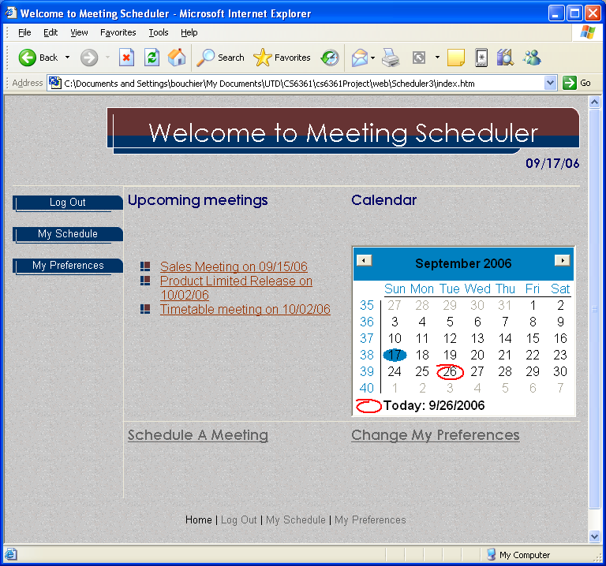Figure 1: Home page

The home page is where the user arrives after logging onto the system.

Figure 2: Create meeting screen

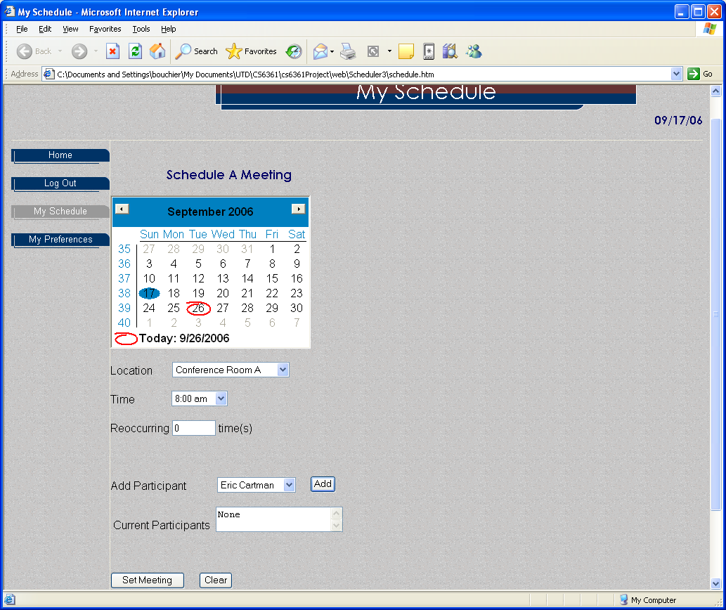The schedule meeting screen allows the user to create a meeting invitation

Figure 3: Meeting preference/exclusion sets & preferences

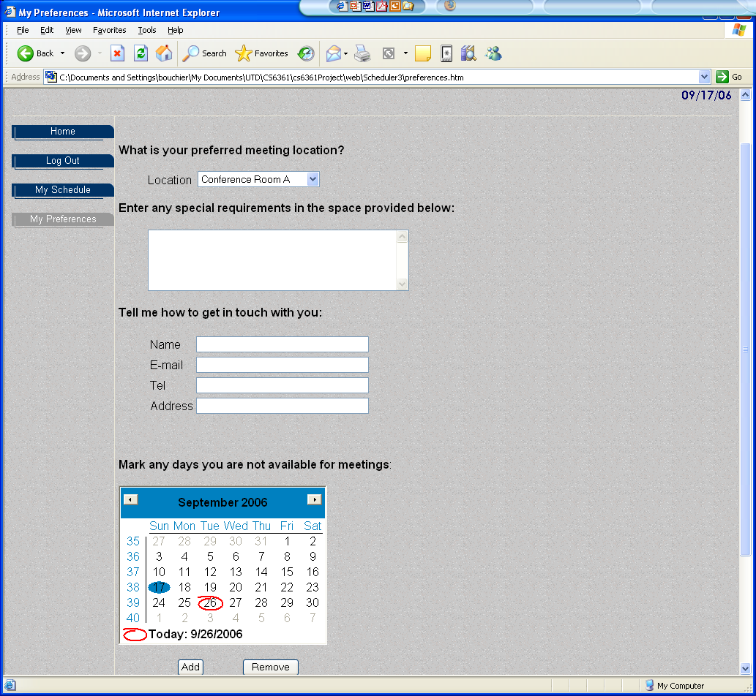The preference/exclusion sets, and user preferences are set on this screen.

## Functions

System functional requirements are specified by use cases and specific requirements. The use case helps understand system behavior, and the specific requirements extend the information from the use case.

### Use Case: 1 Respond To Meeting Invitation

--------------------------------------------------

CHARACTERISTIC INFORMATION

Goal in Context: The user has been notified that they have been invited to a meeting or that it is desired that they attend a meeting. Their goal is to respond by accepting or denying an invitation (if one has been sent) and potentially to update their preference and/or exclusion-set. The method by which they’re notified of a need to access the system is not addressed by this use case. An invitation to which the user should respond may or may not exist (the meeting organizer may have called them to alert them that they should update their preference & exclusion sets in preparation for a meeting he’s going to call).

Scope: Scheduling system

Level: Primary task

Preconditions: User has an account & has logged in successfully, or has finished creating a meeting invitation. User is not the administrator. There are no outstanding invitations that conflict with the exclusion set.

Success End Condition: All outstanding invitations have been accepted or denied, and the user has updated their preference/exclusion sets. No outstanding invitations overlap user’s exclusion set.

Minimal Guarantee: Any invitations that the user accepted or declined have been returned to meeting initiator(s). Others are left outstanding. Any preference/exclusion set changes that the user committed are stored in the system.

Primary Actor: Attendee

Trigger: User logs into system

----------------------------------------

MAIN SUCCESS SCENARIO

1. System shows all outstanding meeting invitations, user’s current meeting schedule, and provides options that allow user to:
   * accept/decline zero or more invitations
   * modify preference/exclusion sets
   * create a meeting invitation
   * check for newly arrived invitations
   * logout
2. User accepts or declines all outstanding invitations
3. System shows user’s current meeting schedule, and provides options that allow user to:
   * modify preference/exclusion sets
   * create a meeting invitation
   * check for newly arrived invitations
   * logout
4. User updates preference/exclusion sets.
5. System shows user’s current meeting schedule, and provides options that allow user to:
   * modify preference/exclusion sets
   * create a meeting invitation
   * check for newly arrived invitations
   * logout
6. User logs out

----------------------

EXTENSIONS

1a There are no invitations:

1a1 system goes to step 3

2a, 4a, 6a User checks for new invitations:

2a1, 4a1, 6a1 system goes to step 1

2b, 4b, 6b User modifies inclusion/exclusion sets:

2b1, 4b1, 6b1 system goes to step 1

2c, 4c, 6c User creates meeting invitation. See use case 2

3a, 5a System displays invitations that arrived during the previous user interaction:

3a1, 5a1 system goes to setp 1

5b User enters an exclusion set item that overlaps a meeting already in the schedule:

5b1: System warns user that they must decline the meeting before they can enter an exclusion date that conflicts with an accepted meeting and asks if they want to decline the accepted meeting. If user says yes, system sends decline to meeting initiator, and removes the meeting from their calendar.

<put here there extensions, one at a time, each refering to the step of the main scenario>

<step altered> <condition> : <action or sub.use case>

<step altered> <condition> : <action or sub.use case>

----------------------

RELATED INFORMATION (optional)

Priority: Must

Performance Target: <the amount of time this use case should take>

Frequency: every login

----------------------------

OPEN ISSUES (optional)

1. Is integration with email, or other tools such as outlook a desirable future enhancement?
2. Need to bring in conference room equipment requirement
3. What should happen if there are multiple updates to an invitation?
4. What should happen to pending invitations that relate to meetings in the past
5. What should happen when a user declines a meeting they had already accepted? Possible approach: resolve based on re-evaluating preference & exclusion sets
6. Another exception: Initiator deletes previously scheduled meeting
7. Do we want the system to offer banner ads?

### Use Case: 2 Initiate a meeting

--------------------------------------------------

CHARACTERISTIC INFORMATION

Goal in Context: The user creates a meeting invitation with maximal overlap with preference sets of all attendees, and no overlap with any attendee’s exclusion set.

Scope: scheduling system

Level: Primary task

Preconditions: User is not an administrator

Success End Condition: Meeting is scheduled for all participants

Minimal Guarantee: A meeting that cannot be scheduled without overlapping a participant’s exclusion set is not accepted by the system

Primary Actor: Meeting initiator

Trigger: User at step 2, 4, or 6 in use case 1 asks to create a new meeting

----------------------------------------

MAIN SUCCESS SCENARIO

1. Initiator enters information about the meeting:
   * meeting name,
   * participants
   * desired date range
   * any known equipment or conference room requirements, or indicates the meeting is virtual

2. System chooses the best date &time & conference room & sends an invitation to attendees and allows user to create another meeting or do other activities in use case 1.

----------------------

EXTENSIONS

2a Meeting initiator is attendee:

2a1 System does not send invitation to initiator

2b Meeting time cannot be found within date range that doesn’t overlap one or more attendees’ exclusion sets:

2b1 System reports names of attendees with exclusion-set violation

2b2 System doubles the date range from the given start date and searches for availability & suggests an alternative that would succeed if such a date is found.

--------------------

SUB-VARIATIONS

<put here the sub-variations that will cause eventual bifurcation in the scenario>

<step or variation # > <list of sub-variations>

<step or variation # > <list of sub-variations>

----------------------

RELATED INFORMATION (optional)

Priority: Must

Performance Target: <the amount of time this use case should take>

Frequency:

Superordinate Use Case: <optional, name of use case that includes this one>

Subordinate Use Cases: <optional, depending on tools, links to sub.use cases>

Channel to primary actor: <e.g. interactive, static files, database>

Secondary Actors: <list of other systems needed to accomplish use case>

Channel to Secondary Actors: <e.g. interactive, static, file, database, timeout>

----------------------------

OPEN ISSUES (optional)

1. What does it mean to “send an invitation”? Is there an email link? Or is it only sending to the account on this tool?
2. In step 2, meeting initiator doesn’t get to confirm that system’s choice of date, location etc is suitable.

----------------------------

NOTES

1. Participants shall have a static preferred location

---------------------------

eractive, static, file, database, timeout>

See section 4 for the process used to analyze the requirements, and to generate the modified system requirements below. Each requirement below has a trace back to the line number in the original requirements specification, which is shown in section 4. They also note if there is a dependency diagram object related to the requirement. Each requirement below that was modified from the original has a Note in the requirement description, which describes how it was modified. SynergySoft reviewers need to review the changes that were made to the delivered requirements, to ensure they are agreeable.

### System Functional Requirements

**3.2.3.1 ) Assist planning meetings [FUN51787** Version:5.9**]**

The system shall assist users in planning meetings under the constraints expressed by participants

Traces from System Functional Requirements lines: 35

Functional Dependency Diagram:

**Requirement Tracing:**

FUN51821 Meeting Notice Requirement BouchierCs6361 Direct TO

FUN51812 Business & Personal use Requirement BouchierCs6361 Direct TO

FUN51792 Bound on replanning Requirement BouchierCs6361 Direct TO

NONFUN51800 Concurrent meetings Requirement BouchierCs6361 Direct TO

NONFUN51809 Performance Requirement BouchierCs6361 Direct TO

NONFUN51810 Privacy Requirement BouchierCs6361 Direct TO

FUN51785 Support organization of meetings Requirement BouchierCs6361 Direct TO

POS51775 Meeting Initiator Requirement BouchierCs6361 Direct FROM

NONFUN51811 Usability Requirement BouchierCs6361 Direct TO

**3.2.3.1.1 ) Support organization of meetings [FUN51785** Version:7.2**]**

The system shall determine, for each meeting request, a meeting date and location so that most of theintended participants will effectively participate

Traces from System Functional Requirements lines: 31-33

Functional Dependency Diagram: Meeting Request, Meeting Date, Meeting Location

**Requirement Tracing:**

FUN51787 Assist planning meetings Requirement BouchierCs6361 Direct FROM

NONFUN51800 Concurrent meetings Requirement BouchierCs6361 Direct TO

**3.2.3.1.2 ) Meeting Notice [FUN51821** Version:1.2**]**

A lower bound of 24 hours should be fixed between the time at which the meeting date is determined and the time at which the meeting is actually taking place;

Traces from System Non-functional Requirements lines 77-78

Functional Dependency Diagram: Lower bound on time between calculation & meeting date

Notes: this requirement was part of the performance requirement in the SynergySoft spec. It was mis-categorized - it is actually a "not earlier than" functional requirement on the meeting date selection. We recategorized it, and after consultation with subject rep, set the bound to 24 hours.

**Requirement Tracing:**

FUN51787 Assist planning meetings Requirement BouchierCs6361 Direct FROM

NONFUN51806 Convenient location available early Requirement BouchierCs6361 Direct TO

**3.2.3.2 ) Assist replanning meetings [FUN51788** Version:4.7**]**

SDMSshall assist users in replanning a meeting to support the changing user constraints, for instance :

* to modify the exclusion set, preference set and/or preferred location before a meetingdate/location is proposed; and

* to take some external constraints into account after a date and location have been proposed - e.g., due to the need to accommodate a more important meeting. ­here, the original meeting date or location may then need to be changed; sometimes the meeting may even be cancelled.

Traces from System Functional Requirements lines: 36-41

Functional Dependency Diagram: Meeting Replanning, changing user constraints

Enterprise Dependency Diagram: Exclusion set, inclusion set,

**Requirement Tracing:**

NONFUN51802 Dynamic flexible replanning Requirement BouchierCs6361 Direct TO

FUN51819 Meeting Importance Requirement BouchierCs6361 Direct TO

NONFUN51809 Performance Requirement BouchierCs6361 Direct TO

NONFUN51810 Privacy Requirement BouchierCs6361 Direct TO

NONFUN51813 Flexibly accommodate evolving data Requirement BouchierCs6361 Direct TO

POS51775 Meeting Initiator Requirement BouchierCs6361 Direct FROM

NONFUN51811 Usability Requirement BouchierCs6361 Direct TO

**3.2.3.2.1 ) Bound on replanning [FUN51792** Version:4.1**]**

After replanning has resulted in 3 changes to a meeting, no more automatic changes will be made, but the initiator can cancel the meeting. Also, the system will not change the meeting date within 24 hours of the meeting start time.

Traces from System Functional Requirements lines: 42

Functional Dependency Diagram: Bound on replanning

Notes: This requirement used to read:In all cases some bound on replanning should be set up. It has been changed to explicitely state the bound, after consultation with user & subject reps.

**Requirement Tracing:**

FUN51787 Assist planning meetings Requirement BouchierCs6361 Direct FROM

**3.2.3.2.2 ) Meeting Importance [FUN51819** Version:2.1**]**

The initiator shall state the importance of the meeting on a scale of 1 - 10.

Rationale: The importance shall be used to prioritize meetings when a more important meeting is to take precedence, which may force cancellation of the meeting (line 41).

Notes: The SynergySoft spec didn't contain this requirement, but implied the need for it in line 41. After consultation we have added this requirement.

**Requirement Tracing:**

FUN51788 Assist replanning meetings Requirement BouchierCs6361 Direct FROM

**3.2.3.3 ) Business & Personal use [FUN51812** Version:3.2**]**

The system should be customizable to professional as well as private meetings - these two modes of use are characterized by different restrictions on the time periods that may be allocated (e.g., meetings during office hours, private activities during leisure time). The system shall allow the initiator to set a time of day range that is allowed for the meeting start time. The default shall be 9am - 5pm.

Traces from System Non-functional Requirements lines: 82-84

Functional Dependency Diagram: Initiate Meeting

Notes: This was a non-functional requirement in the SynergySoft spec. After consultation with subject rep, we decided it is not actually a non-functional requirement for customizability, but a functional requirement to be able to set the range of hours for starting the meeting. Accordingly, it is moved to functional requirements.

**Requirement Tracing:**

FUN51787 Assist planning meetings Requirement BouchierCs6361 Direct FROM

**3.2.3.4 ) Conflict Resolution Policies [FUN51793** Version:2.2**]**

The system shall support conflict resolution according to resolution policies stated by the initiator

Traces from System Functional Requirements lines: 43

Functional Dependency Diagram: Resolution policies, Client

Notes: changed ".. by the client" to "... by the initiator". There's no other mention of a client in the SynergySoft spec, and our user rep thinks it makes most sense for an inititator to specify conflict resolution policies.

**Requirement Tracing:**

POS51770 Conflict Resolution Policies Requirement BouchierCs6361 Direct FROM

NONFUN51808 Physical constraints not broken Requirement BouchierCs6361 Direct TO

**3.2.3.5 ) Manage Participant Interactions [FUN51794** Version:2.7**]**

The system shall manage all the interactions among participants required during the organization of the meeting

Traces from System Functional Requirements lines: 44

Functional Dependency Diagram:

**Requirement Tracing:**

FUN51795 Communicate Requests Requirement BouchierCs6361 Direct TO

FUN51796 Get replies Requirement BouchierCs6361 Direct TO

FUN51798 Keep participants informed Requirement BouchierCs6361 Direct TO

NONFUN51803 Minimize interactions Requirement BouchierCs6361 Direct TO

NONFUN51799 Instill confidence Requirement BouchierCs6361 Direct TO

POS51815 Any user can create meeting Requirement BouchierCs6361 Direct FROM

FUN51797 Negotiation & conflict resolution Requirement BouchierCs6361 Direct TO

**3.2.3.5.1 ) Communicate Requests [FUN51795** Version:3.2**]**

The system shall communicate meeting requests to participants by sending email and by showing meeting requests on the scheduler web page

Traces from System Functional Requirements lines: 45

Functional Dependency Diagram:

Notes: The SynergySoft spec didn't specify how communication should occur. After consultation with user & subject reps, we agreed that email and display on the scheduler web page should be the methods used. We will alert SynergySoft that this requirement modification implies an interface to email systems, which may be a significant effort. We believe this is important to making the product useful.

**Requirement Tracing:**

NONFUN51806 Convenient location available early Requirement BouchierCs6361 Direct TO

FUN51794 Manage Participant Interactions Requirement BouchierCs6361 Direct FROM

**3.2.3.5.2 ) Get replies [FUN51796** Version:3.1**]**

The system shall remind participants who haven't responded promptly to a meeting invitation, by sending them email and cc'ing the meeting initiator.

Traces from System Functional Requirements lines: 46

Functional Dependency Diagram:

Notes:

This requirement used to say, "system shall get replies even from participants not reacting promptly". It was not feasible as stated - the system can't bang someone on the head and make them reply. We rewrote it after consultation with user & subject reps, to send reminder email and to alert the initiator, who can bang someone on the head.

**Requirement Tracing:**

FUN51794 Manage Participant Interactions Requirement BouchierCs6361 Direct FROM

**3.2.3.5.3 ) Negotiation & conflict resolution [FUN51797** Version:3.1**]**

The system shall support the negotiation and conflict resolution processes

Traces from System Functional Requirements lines: 47

Functional Dependency Diagram: Conflict resolution, Resolution policies

**Requirement Tracing:**

POS51769 Date Conflict Requirement BouchierCs6361 Direct FROM

FUN51794 Manage Participant Interactions Requirement BouchierCs6361 Direct FROM

**3.2.3.5.4 ) Keep participants informed [FUN51798** Version:2.1**]**

The system shall make participants aware of what's going on during the planning process; keep participants informed about schedules and their changes;

Traces from System Functional Requirements lines: 48-49

Functional Dependency Diagram:

**Requirement Tracing:**

FUN51794 Manage Participant Interactions Requirement BouchierCs6361 Direct FROM

**3.2.3.6 ) Administrative Account [FUN51820** Version:3.1**]**

There shall be an administrative user account, which shall be authorized to add and remove and modify user accounts, rooms, equipment, and virtual meeting characteristics from the system.

Notes: The whole administration area was not addressed in the SynergySoft spec. After consultation with the domain rep we decided these are the functions that should be performed by an administrator.

**Requirement Tracing:**

POS51818 System Administrator Requirement BouchierCs6361 Direct FROM

### Nonfunctional Requirements

**3.2.4.1 ) Dynamic flexible replanning [NONFUN51802** Version:7.1**]**

Replanning of a meeting should be done as dynamically and with as much flexibility as possible

Traces from System Non-functional Requirements lines: 58

Non-functional Dependency Diagram: Flexible to changing data

**Requirement Tracing:**

FUN51788 Assist replanning meetings Requirement BouchierCs6361 Direct FROM

**3.2.4.2 ) Concurrent meetings [NONFUN51800** Version:3.2**]**

The meeting scheduler system must in general handle several meeting requests in parallel. Meeting requests can be competing when they overlap in time or space. Concurrency must thus be managed

Traces from System Functional Requirements lines: 52-53

Functional Dependency Diagram:

Notes: This requirement was in the functional requirements section of the SynergySoft spec, but it was mis-categorized - it is a non-functional requirement. It has been moved to the non-functional requirements section.

**Requirement Tracing:**

FUN51787 Assist planning meetings Requirement BouchierCs6361 Direct FROM

FUN51785 Support organization of meetings Requirement BouchierCs6361 Direct FROM

**3.2.4.3 ) Minimize interactions [NONFUN51803** Version:3.1**]**

The amount of interaction among participants (e.g., number and length of messages, amount of negotiation required) should be kept minimal

Traces from System Non-functional Requirements lines: 59-60

Non-functional Dependency Diagram: Minimal interaction

**Requirement Tracing:**

FUN51794 Manage Participant Interactions Requirement BouchierCs6361 Direct FROM

**3.2.4.4 ) Instill confidence [NONFUN51799** Version:3.1**]**

The system shall make participants confident about the reliability of the communications

Traces from System Functional Requirements lines: 50

Functional Dependency Diagram:

Notes: This requirement was in the functional requirements section of the SynergySoft spec, but it was mis-categorized - it is a non-functional requirement. It has been moved to the non-functional requirements section.

**Requirement Tracing:**

FUN51794 Manage Participant Interactions Requirement BouchierCs6361 Direct FROM

**3.2.4.5 ) Reflects current meeting management [NONFUN51805** Version:3.1**]**

The system should reflect as closely as possible the way meetings are typically managed (see the domain theory above)

Traces from System Non-functional Requirements lines: 64

Non-functional Dependency Diagram:

**Requirement Tracing:**

POS51815 Any user can create meeting Requirement BouchierCs6361 Direct FROM

**3.2.4.6 ) Convenient location available early [NONFUN51806** Version:4.1**]**

The meeting date and location should be as convenient as possible, and available as early as possible, to all invitees

Traces from System Non-functional Requirements lines: 66-67

Non-functional Dependency Diagram: Convenient meetings

Notes: We changed "(potential) participants" to "invitees" for consistency of terminology

**Requirement Tracing:**

FUN51795 Communicate Requests Requirement BouchierCs6361 Direct FROM

FUN51821 Meeting Notice Requirement BouchierCs6361 Direct FROM

**3.2.4.7 ) Decentralized requests [NONFUN51807** Version:3.1**]**

The system should accommodate as much decentralized requests as possible; any authorized user should be able to request a meeting independently of her whereabouts

Traces from System Non-functional Requirements lines: 68-69

Non-functional Dependency Diagram: Decentralized

**Requirement Tracing:**

POS51815 Any user can create meeting Requirement BouchierCs6361 Direct FROM

**3.2.4.8 ) Physical constraints not broken [NONFUN51808** Version:3.1**]**

Physical constraints should not be broken - e.g., a person may not be at two different placesat the same time; a meeting room may not be allocated to more than one meeting at the same time; etc.

Traces from System Non-functional Requirements lines: 70-71

Non-functional Dependency Diagram: Physical constraints not broken

**Requirement Tracing:**

FUN51793 Conflict Resolution Policies Requirement BouchierCs6361 Direct FROM

**3.2.4.9 ) Performance [NONFUN51809** Version:4.1**]**

The system should provide an appropriate level of performance:

* the elapsed time between the submission of a meeting request and the determination of the corresponding date/location should me minimal; and

* the elapsed time between the determination of a meeting date/location and the communication of this information to all participants concerned should be minimal;

Traces from System Non-functional Requirements lines: 72-78

Non-functional Dependency Diagram: Quick communication to participants, Appropriate level of performance, Minimal time to determine meeting info,

Notes: The 1st & 2nd bullet used to say "OR". We changed it to "AND" because both requirements must be met. The 3rd bullet in the SynergySoft spec (lines 77-78) was actually a functional requirement, so we created a new functional requirement, "Meeting Notice" and moved the 3rd bullet into it.

**Requirement Tracing:**

FUN51787 Assist planning meetings Requirement BouchierCs6361 Direct FROM

FUN51788 Assist replanning meetings Requirement BouchierCs6361 Direct FROM

**3.2.4.10 ) Privacy [NONFUN51810** Version:4.1**]**

Privacyrules should be enforced; no participant is allowed to see constraints stated by other participants

Traces from System Non-functional Requirements lines: 79-80

Non-functional Dependency Diagram: Privacy

Notes: The synergysoft spec called for non-privileged participants to be unable to see constraints set by other users. However, the concept of who a privileged participant is, and what privileges they have was not stated. After consultation with subject rep we decided all participants are non-privileged - none of them can be allowed to see other participants' contstraints.

**Requirement Tracing:**

FUN51787 Assist planning meetings Requirement BouchierCs6361 Direct FROM

FUN51788 Assist replanning meetings Requirement BouchierCs6361 Direct FROM

**3.2.4.11 ) Usability [NONFUN51811** Version:2.1**]**

The system should be usable by non-experts

Traces from System Non-functional Requirements lines: 81

Non-functional Dependency Diagram: User Friendly

**Requirement Tracing:**

FUN51787 Assist planning meetings Requirement BouchierCs6361 Direct FROM

FUN51788 Assist replanning meetings Requirement BouchierCs6361 Direct FROM

**3.2.4.12 ) Flexibly accommodate evolving data [NONFUN51813** Version:2.1**]**

The system should be flexible enough to accommodate evolving data - e.g., the sets of concerned participants may be varying, the address at which a participant can be reached may be varying, etc.

Traces from System Non-functional Requirements lines: 85-86

Non-functional Dependency Diagram: Flexible to changing data

**Requirement Tracing:**

FUN51788 Assist replanning meetings Requirement BouchierCs6361 Direct FROM

**3.2.4.13 ) Extensible [NONFUN51814** Version:2.1**]**

The system should be easily extensible to accommodate the following typical variations:

* handling of explicit priorities among dates in preference sets;

* handling of explicit dependencies between meeting date and meeting location;

* participation through delegation - a participant may ask another person to represent her/him at the meeting;

* variations in date formats, address formats, interface language, etc.; and

* partial reuse in other contexts - e.g., to help establish course schedule

Traces from System Non-functional Requirements lines: 87-93

Non-functional Dependency Diagram: Extensible

**Requirement Tracing:**

POS51815 Any user can create meeting Requirement BouchierCs6361 Direct FROM

### Deleted Requirements

**3.2.5.1 ) Monitor meetings [DLTD51786** Version:4.0**]**

System shall assist users in Monitoring meetings, especially when they are held in a distributed manner

Traces from Enterprise Requirements lines: 34

Enterprise Dependency Diagram: Meeting Monitoring

Notes: After discussion with developer, user & subject reps, we decided monitoring should not be part of a scheduling system. If a monitoring system is needed, it should be a separate system. Therefore this requirement and the associated non-funtional requirement are deleted from the requirement set. We will point this out to SynergySoft.

Rationale:

1) It was suggested in the review that "monitoring" could be interpreted as meaning monitoring changes in user schedules, exclusion sets etc. and how they interact with scheduled meetings. We don't think the SynergySoft spec supports that interpretation - it says, "Monitor meetings, especially when they are held in a distributed manner" so it is talking about monitoring meetings, not monitoring participant schedule changes.

2) the functions of monitoring are too different from the functions of scheduling that they should not be combined.

3) the monitoring function is not described in the SynergySoft spec. SynergySoft needs to describe what this feature should do.

**3.2.5.2 ) Accurate Monitoring [DLTD51801** Version:5.0**]**

A meeting should be accurately monitored, especially when it is held in a virtual place. Here, nomadicity will then be important to consider;

Traces from System Non-functional Requirements lines: 56-57

Non-functional Dependency Diagram: Accurate

Notes: This requirement is deleted. See DLTD1786 - Monitor Meetings for an explanation

**3.2.5.3 ) Reduce overhead [DLTD51804** Version:4.0**]**

The intended system should considerably reduce the amount of overhead usually incurred in

* organizing meetings where potential attendees are distributed over many different places and

* communicate with each other, for example, via Internet

Traces from System Non-functional Requirements lines: 61-63

Non-functional Dependency Diagram: Reduced overhead

Notes: We are deleting this requirement because it is redundant with "Minimize Interactions" non-functional requirement

### System Non-functional Requirements

### Deleted Requirements

# Requirements Analysis – Paul & Shaun

This section describes the team, their roles, and the process used to analyze the requirements and create the dependency analysis. It lists the requirements issues that were discovered, and how they were resolved. It includes the original specification, annotated with line numbers. These line numbers are referenced in the issue resolutions and in the improved requirements in section 3.

## Analysis Team and Roles - Paul

Paul Bouchier: Requirements Engineer & team lead

Jon Fischer: User world representative

Chris Nina: Developer world representative

Shaun Herschbach: Subject world representative

## Analysis Process

This section describes how we analyzed the requirements, and what the dependencies mean.

Each line in the Enterprise requirements was analyzed and recast where necessary to fix issues. The SynergySoft requirements document was scanned & OCR’d, and the text extracted into the requirements management tool CaliberRM. After requirements were inserted, the requirements were analyzed for consistency, completeness, testability, correct categorization, and other requirements faults. Faults were corrected after consultation with subject & user representatives. The notes section of each requirement tells how it was modified from the original. The original requirements can be seen, along with line numbers, in section 4. Tracing was added to connect requirements.

## Dependency Analysis

Each concept in the Enterprise requirements was analyzed for meaning and dependencies and unresolved issues (dependencies could not be identified). The figure below shows which concepts or actions depend on each other in the enterprise requirements after the requirements refinement and issue resolution. A depends on B means without B there can be no A

### Enterprise Requirements Analysis

The refined (better understanding) dependency diagram for concepts in the system functional requirements is shown below

.

Figure 4: Enterprise Dependency Diagram

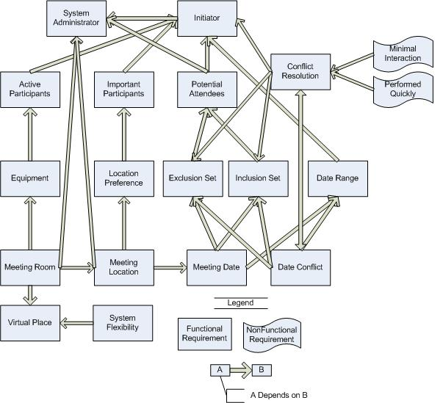

### System Functional Requirements Analysis

The refined (better understanding) dependency diagram for concepts in the system functional requirements is shown below

Figure 5: System Functional Dependencies (refined)

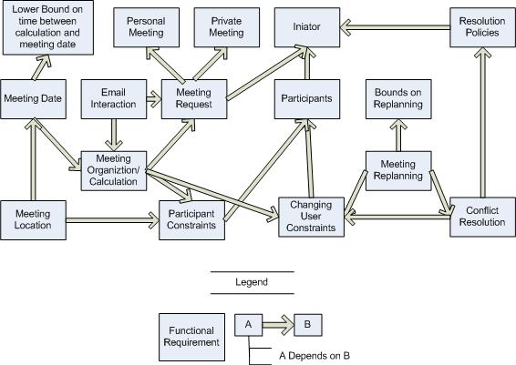

### System Nonfunctional Requirements Analysis

The refined (better understanding) dependency diagram for concepts in the system non-functional requirements is shown below.

Figure 6: System non-functional dependencies (refined)

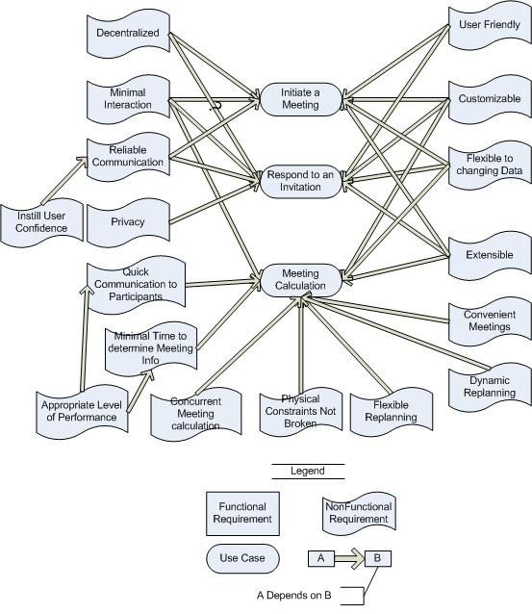

## Issues Raised to SynergySoft - Shaun

* Drop the Monitoring requirement
* Add an email requirement
* Perform a market analysis to determine the size of the market and type of user who would use this system, considering it is not integrated with Microsoft Outlook, Novell Netware, or any other calendar system.

## Original Requirements Delivered by SynergySoft

This section contains the original requirements set which SynergySoft delivered for analysis. The requirements have been annotated with line numbers, which are referenced elsewhere in this document.

### ORIGINAL Enterprise Requirements: Stakeholders, Functional and Non-Functional Objectives

In the application domain. meetings are typically arranged in the following manner. A *meeting initiator* will ask all *potential meeting attendees* for the following information based on their personal agenda:

* a set of dates on which they cannot attend the meeting (hereafter referred to as *exclusion set;* and
* a set of dates on which they would prefer the meeting to take place (hereafter referred to as *preference set);*

A meeting date shall be defined perhaps by a pair (calendar date, time period). The exclusion and preference sets should be contained in some time interval prescribed by the meeting initiator (hereafter referred to as *date range).*

The initiator could also ask, in a friendly manner, *active participants* to provide any special equipment requirements on the meeting location (e.g., overhead projector, workstation, network connection, telephone, etc.). She may also ask *important participants* to state preferences about the meeting location.

The proposed meeting date should belong to the stated date range and to none of the exclusion sets; furthermore it should ideally belong to as many preference sets as possible. The proposal should be made as early as possible. A *date conflict* occurs when no such date can be found. A conflict is strong when no date can be found within the date range and outside all exclusion sets; it is weak when dates can be found within the date range and outside all exclusion sets, but no date can be found at the intersection of all preference sets.

Conflicts can be resolved in several ways, including:

* the initiator extends the date range; and
* some participants remove some dates from their exclusion set.
* some participants withdraw from the meeting;
* some participants add some new dates to their preference set.

Each conflict resolution should be done as quickly as possible and with no more interactions than is

really needed.

A meeting room must be available at the selected meeting date. It should meet the equipment requirements; furthermore it should ideally belong to one of the locations preferred by as many important participants as possible. It is absolutely necessary, however, to allow each meeting to take place in a virtual place, e.g., through teleconferencing using laptop computers. This flexibility is considered crucial in future. The number of negotiations should be kept minimal. but a new round of negotiation may be required when no such room can be found.

The meeting initiator can be one of the participants or some representative (e.g., a secretary).

### ORIGINAL System Requirements: Functional Requirements

The purpose of SDMS is to support the organization of meetings - that is, to determine, for each meeting request, a meeting date and location so that most of the intended participants will effectively participate. SDMS shall assist users in the following activities:

* Monitor meetings, especially when they are held in a distributed manner;
* Plan meetings under the constraints expressed by participants (see domain theory);
* Replan a meeting to support the changing user constraints, for instance:
* to modify the exclusion set, preference set and/or preferred location before a meeting

date/location is proposed; and

* to take some external constraints into account after a date and location have been proposed - e.g., due to the need to accommodate a more important meeting. ­here, the original meeting date or location may then need to be changed; sometimes the meeting may even be cancelled.

In all cases some bound on replanning should be set up.

* Support conflict resolution according to resolution policies stated by the client;
* Manage all the interactions among participants required during the organization of the meeting, for instance:
  + to communicate requests;
  + to get replies even from participants not reacting promptly;
  + to support the negotiation and conflict resolution processes;
  + to make participants aware of what's going on during the planning process; - to keep participants informed about schedules and their changes; and
  + to make them confident about the *reliability* of the communications.

The meeting scheduler system must in general handle several meeting requests in parallel. Meeting requests can be competing when they overlap in time or space. Concurrency must thus be managed.

### ORIGINAL System Non-Functional Requirements

In meeting the functional requirements, *non-functional requirements* should also be taken account. They include:

* A meeting should be *accurately* monitored, especially when it is held in a virtual place. Here, *nomadicity* will then be important to consider;
* Replanning of a meeting should be done as *dynamically* and with as much *flexibility* as possible;
* The amount of interaction among participants (e.g., number and length of messages, amount of negotiation required) should be kept *minimal;*
* The intended system should *considerably reduce the amount of overhead* usually incurred in
  + organizing meetings where potential attendees are distributed over many different places and
  + communicate with each other, for example, via Internet;
* The system should reflect as closely as possible the way meetings are typically managed (see the domain theory above);
* The meeting date and location should be as *convenient* as possible, and available as *early* as possible, to all (potential) participants;
* The system should accommodate as much decentralized requests as possible; any authorized user should be able to request a meeting independently of her whereabouts;
* Physical constraints should not be broken - e.g., a person may not be at two different places at the same time; a meeting room may not be allocated to more than one meeting at the same time; etc.;
* The system should provide an appropriate level of p*erformance:*
  + the elapsed time between the submission of a meeting request and the determination of the corresponding date/location should me *minimal;* or
  + the elapsed time between the determination of a meeting date/location and the communication of this information to all participants concerned should be *minimal;* or
  + a lower bound should be fixed between the time at which the meeting date is determined and the time at which the meeting is actually taking place;
* *Privacy* rules should be enforced; a non-privileged participant should not be aware of constraints stated by other participants;
* The system should be *usable* by non-experts;
* The system should be *customizable* to professional as well as private meetings - these two modes of use are characterized by different restrictions on the time periods that may be allocated (e.g., meetings during office hours, private activities during leisure time);
* The system should be *flexible* enough to accommodate evolving data - e.g., the sets of concerned participants may be varying, the address at which a participant can be reached may be varying, etc.;
* The system should be easily *extensible* to accommodate the following typical variations:
  + handling of explicit priorities among dates in preference sets;
  + handling of explicit dependencies between meeting date and meeting location;
  + participation through delegation - a participant may ask another person to represent her/him at the meeting;
  + variations in date formats, address formats, interface language, etc.; and
  + partial *reuse* in other contexts - e.g., to help establish course schedule.